Open Industry 4.0 Alliance and Packaging Valley to shape Industry 4.0 together
The two organisations aim to jointly realise cross-manufacturer integration in the packaging industry with a focus on master data management, plant analytics and predictive maintenance

Reinach, Switzerland/ Waiblingen, Germany, September 6, 2021 – The Open Industry 4.0 Alliance, an association of companies aiming to drive digitalisation on factory floors, is working with Packaging Valley Germany e.V., a cluster of organisations from the packaging industry in the south of Germany. Packaging Valley currently has 90 members, including manufacturers of packaging systems, packaging machines and their components; providers of software, automation solutions and services; and cooperation partners. The common goal of both associations is the practice-oriented transformation of companies to cross-platform Industry 4.0. Joint working groups will implement standards for practice and develop best use cases in the packaging industry.

Goals for machine builders in the packaging industry

The Open Industry 4.0 Alliance sees great potential in line-related services and in bringing together data and information from an entire production environment. The goal of integration without manual intervention can become a reality through the development of concrete application scenarios for the packaging industry. With such ready-made integration kits, members of the two associations will be able to implement digital transformation very quickly – for example, with uniform structuring and semantics of the operating resources (assets), improved effectiveness of the entire plant (OEE) and deployment of modern methods such as predictive maintenance, which further minimises downtime.

The applications are primarily:

- Master data management: Uniform structuring and presentation of the connected operating resources (assets), optimally with joint application or integration of the concept of the management shell as an essential step in the transformation
- Plant analytics: Analysis of OEE (Overall Equipment Effectiveness) and condition monitoring, both across individual production lines and entire production, so that there is more transparency regarding the efficiency of a production plant
- Information on predictive maintenance for machines from different manufacturers. Displayed in a dashboard, users learn when a machine is in danger of failing. This results in fewer maintenance breaks and reduced downtime

Overall, the Open Industry 4.0 Alliance wants to implement its vision of end-to-end networking from the machine to the cloud through its proposed architecture, comprising four levels from the factory floor to the cloud. With the help of integration from other machine manufacturers in the packaging industry, this should become a reality even faster.

"OEMs from the packaging machine industry in particular can use the Open Industry 4.0 Alliance as a joint platform to develop interoperable Industry 4.0 products for their customers in the pharmaceutical, medical, food and consumer goods sectors," says Dr Marius Grathwohl, Chairman Industry Focused Workgroups of the Open Industry 4.0 Alliance and Vice President Digital Products and Transformation at MULTIVAC Group. "We place great emphasis on teamwork and there will be regular exchanges with Packaging Valley's 'Technology Trends’ working group and representatives of the Alliance."

For the Packaging Valley Germany cluster, the topics of sustainability and technology are the focus of activities. In the Technology Trends working group, the member companies deal with innovative technologies and their fields of application, which are strongly characterised by digitalisation. In addition to the topics that can be subsumed under the term Industry 4.0, it is technologies such as artificial intelligence, digital engineering, VR/AR and sustainable plant design that are dealt with jointly by the working group.

"By cooperating with the Open Industry 4.0 Alliance, Packaging Valley expects even more implementation orientation and very practical projects," says Sabine Gauger, Chairwoman of Packaging Valley Germany e.V. and Managing Support Manager at OPTIMA packaging group GmbH. "Companies like Balluff, Harro Höflinger, Murrelektronik and Optima are already members of both Packaging Valley and the Alliance, so cooperation on concrete use cases is an obvious step. For us as a packaging industry cluster, this cooperation offers the potential for real added value."

Event notes:

"FACHPACK" in Nuremberg from 28 to 30 September 2021
Packaging Valley will be present at the packaging trade fair with 23 members. 14 of them are represented at a joint stand in Hall 3C / Stand 237. Plant manufacturers, component manufacturers, automation companies and service providers will present themselves clearly and compactly.

More info: Packaging Valley auf der FACHPACK 2021

"Digitize your Food" on 6 and 7 October at Multivac in Wolfertschwenden
The Open Industry 4.0 Alliance and MULTIVAC invite customers and interested parties from the food and packaging industry to experience the Alliance's digital transformation first-hand. At Multivac's headquarters in the Allgäu region of Germany, Multivac and the Alliance will provide an insight into the development of digital strategies, their implementation and ultimately the exploitation of optimisation potential in day-to-day operations.

Information and registration at: https://event.openindustry4.com/

LinkedIn: https://www.linkedin.com/company/open-industry-4-0-alliance/
Hashtag: #OI4Alliance

LinkedIn: https://de.linkedin.com/company/packaging-valley-germany-e-v-
Hashtag: #packagingvalley

Image material:

Sabine Gauger  Chairwoman Packaging Valley Germany e.V. / OPTIMA | Dr. Marius Grathwohl  Chairman Industry Focused Workgroups of the Open Industry 4.0 Alliance / MULTIVAC
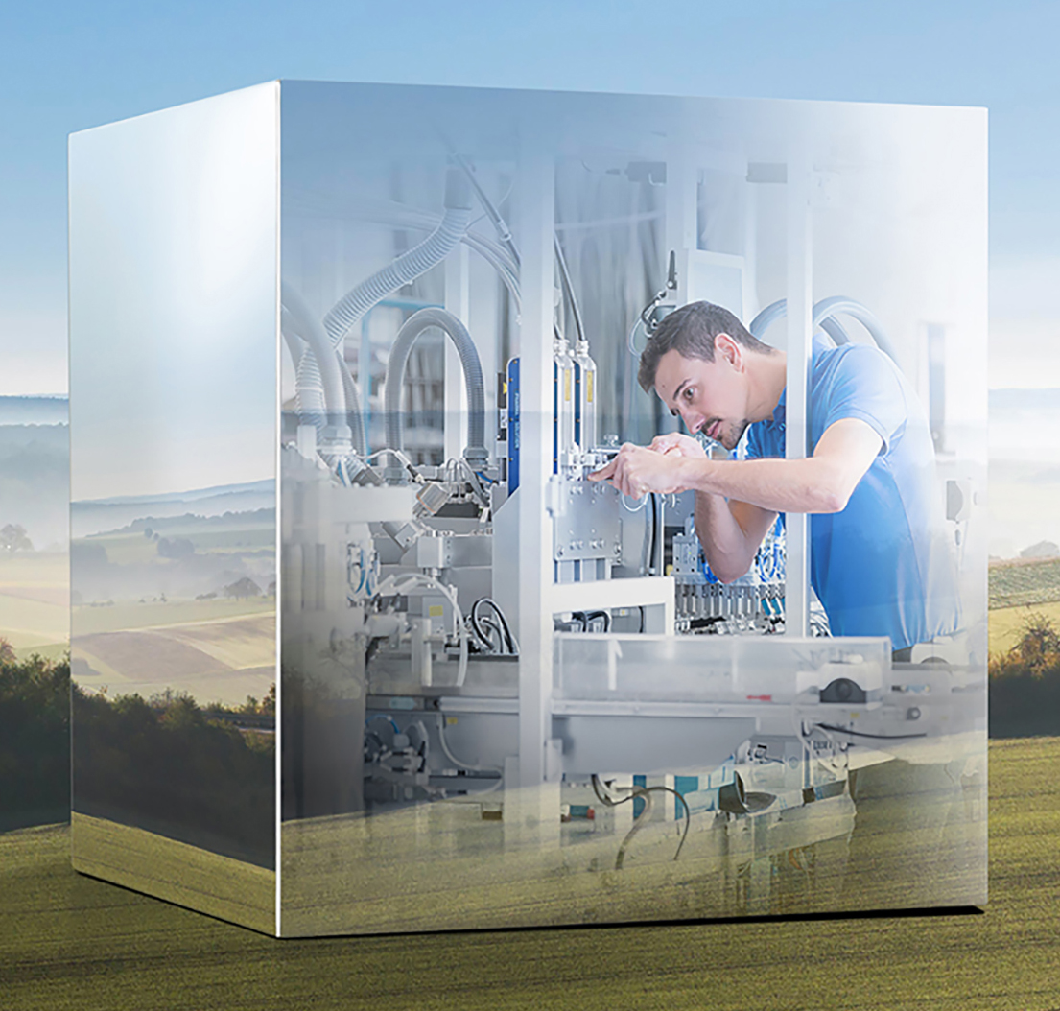
Packaging Valley and the Open Industry 4.0 Alliance want to jointly drive the transformation of the packaging industry (Credits: Packaging Valley e.V.)

Please request high-resolution image material from Berkeley Kommunikation.

About Packaging Valley e.V.
Founded in 2007 in Schwäbisch Hall, Packaging Valley Germany e. V. is a packaging industry cluster in the southwest of Germany. It emerged from a merger of the Packaging Valley Germany and Packaging Excellence Region Stuttgart clusters. It networks around 90 companies with a total of over 25,000 employees. These include manufacturers of packaging systems and packaging machines, providers of software and automation solutions, manufacturers of components, providers of services related to the packaging industry as well as public institutions.The "Valley" extends from the association's headquarters in Waiblingen across the entire area between Frankfurt, Nuremberg and the Stuttgart metropolitan region.

More under: https://www.packaging-valley.com

About the Open Industry 4.0 Alliance
The Open Industry 4.0 Alliance acts as a partnership of leading European industrial companies that pragmatically participate in the implementation of cross-vendor industry 4.0 solutions and services for manufacturing facilities and automated warehouses. The Alliance was launched in April 2019. The association is headquartered in Reinach, Switzerland.

Further information can be found at https://www.openindustry4.com/

Press contacts:

Nils Herzberg, Spokesman of the Board Open Industry 4.0 Alliance
Global Head Strategic Partnerships for Digital Supply Chain and Industry 4.0 SAP
E-mail: info@openindustry4.com

Regine Rüeck, Packaging Valley Germany e.V.
Marketing- und Eventmanagement
Phone: +49 791 580 114
E-mail: regine.rueeck@packaging-valley.com

Ulrike Götz, Open Industry 4.0 Alliance PR Lead
Phone: +49 170 70 69 613
E-mail: Ulrike.Goetz@kuka.com

Patrick Wandschneider, Berkeley Kommunikation GmbH
Phone +49 89 747 262 41
E-mail: patrick.wandschneider@berkeleypr.com

